## 

## **Practical-2**

**Student Name:** Gauri Prabhakar **UID:** 18BCS6201

**Branch:** 18AITAIML-2 **Section/Group:** B

**Semester:** 7 **Date of Performance:** 3rd September, 2021

**Subject Name:** Computer Vision Lab **Subject Code:** CSF - 432

# Aim/Overview of the practical:

To demonstrate the use of different image processing functions using python and OpenCv.

# Task to be done:

To demonstrate the use of different image processing functions using python and OpenCv and the explanation.

# Steps to be followed:

1. Importing necessary modules.
2. Converting an image to Grayscale.
3. Creating a variable to store the image using the '.imread()' function.
4. Creating a variable to store the grayscale image using the function '.cvtColor()'.
5. Returning the modified image.
6. Setting up '.waitkey()' to wait for a specific time until any key is pressed.
7. Destroying all windows.
8. Creating a variable to store the edge detected image using the function '.Canny()'.
9. Returning the modified image.
10. Creating a variable to store the average blurred image using the function '.blur()'.
11. Creating a variable to store the median blurred image using the function '.medianBlur()'
12. Creating a variable to store the gaussian blurred image using the function '.GaussianBlur()'.
13. Returning the image.
14. Returning the modified image.
15. 'np.ones()' returns an array of 1's of the given shape, data type.
16. Creating a variable to store the eroded image using the function '.erode()'.
17. Creating a variable to store the dilated image using the function '.dilate()'
18. Returning the image.
19. Returning the modified image.
20. Returning the shape of the image in the form of an array.
21. Resizing the image.
22. Cropping the image.
23. Returning the image.
24. Returning the modified image.
25. Drawing a line on the image, it takes parameters as image, start point, end point, color and finally thickness.
26. Drawing a rectangle on the image, it takes parameters as image, start point, end point, color and finally thickness.
27. Drawing a circle on the image, it takes parameters as image, center co-ordinates, radius, color and finally thickness.
28. Writing a text on the image, it takes parameters as image, text, co-ordinates, font, font scale, color, thickness.
29. Returning the modified image.
30. **Result/Output/Writing Summary:**

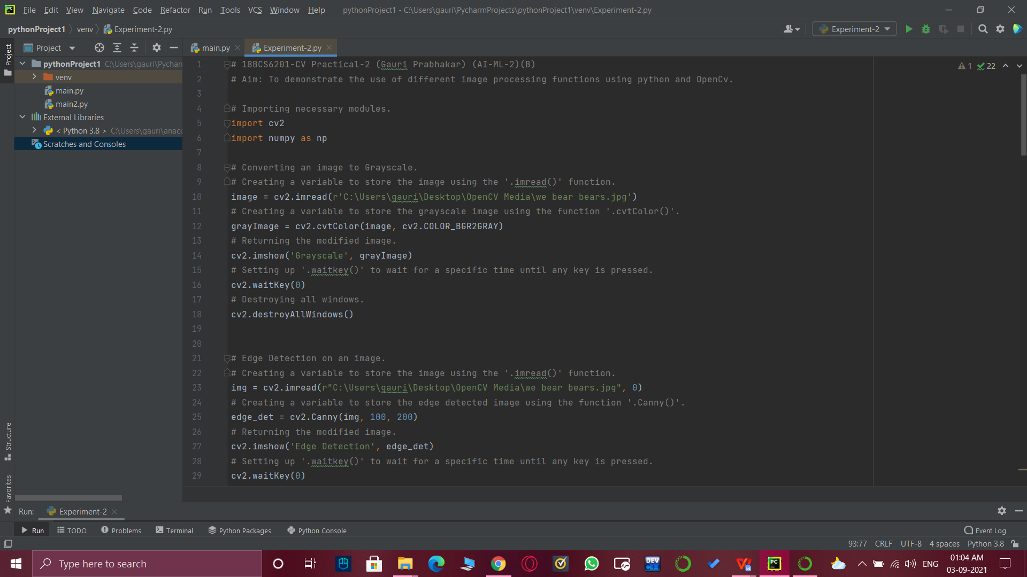

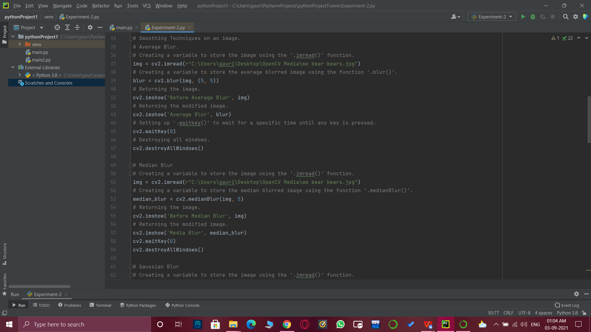

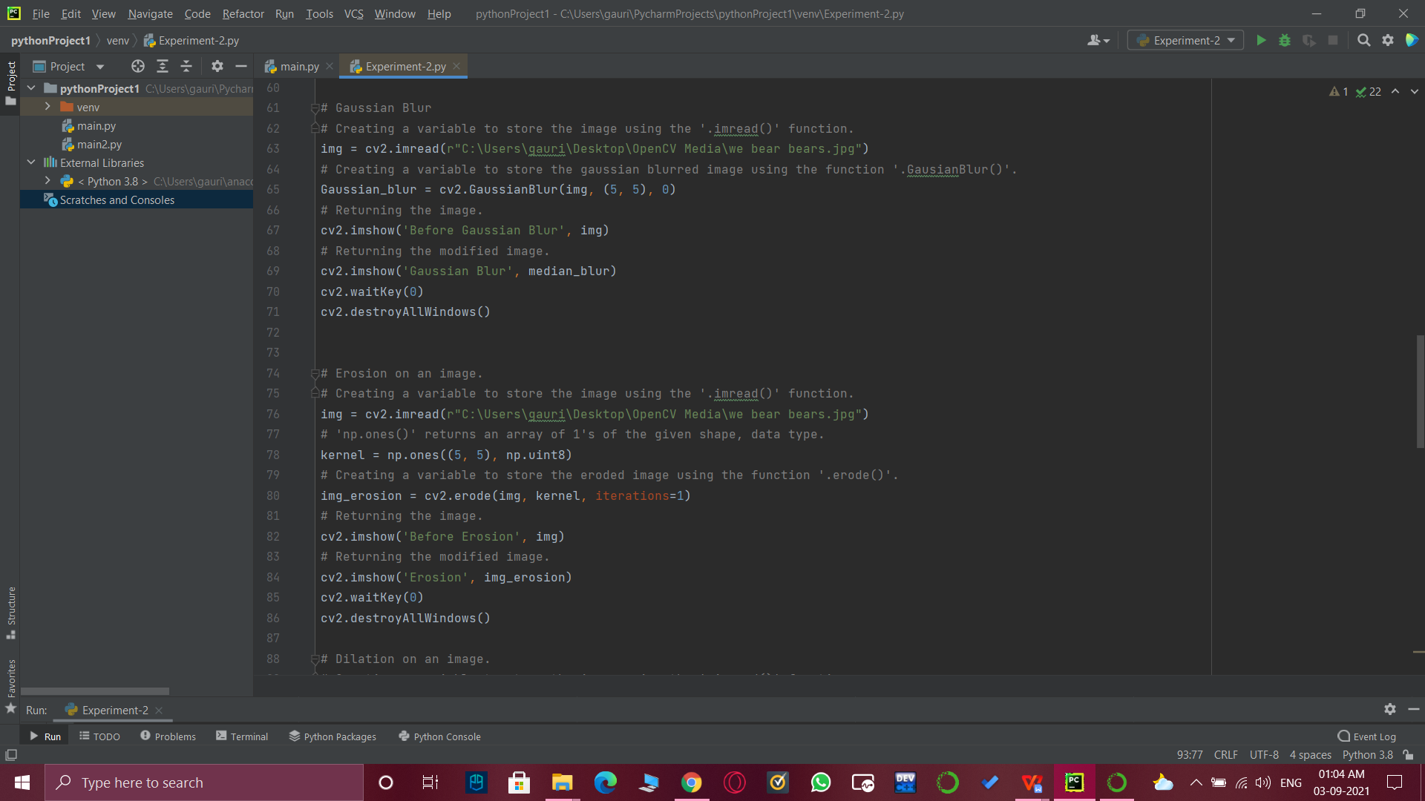

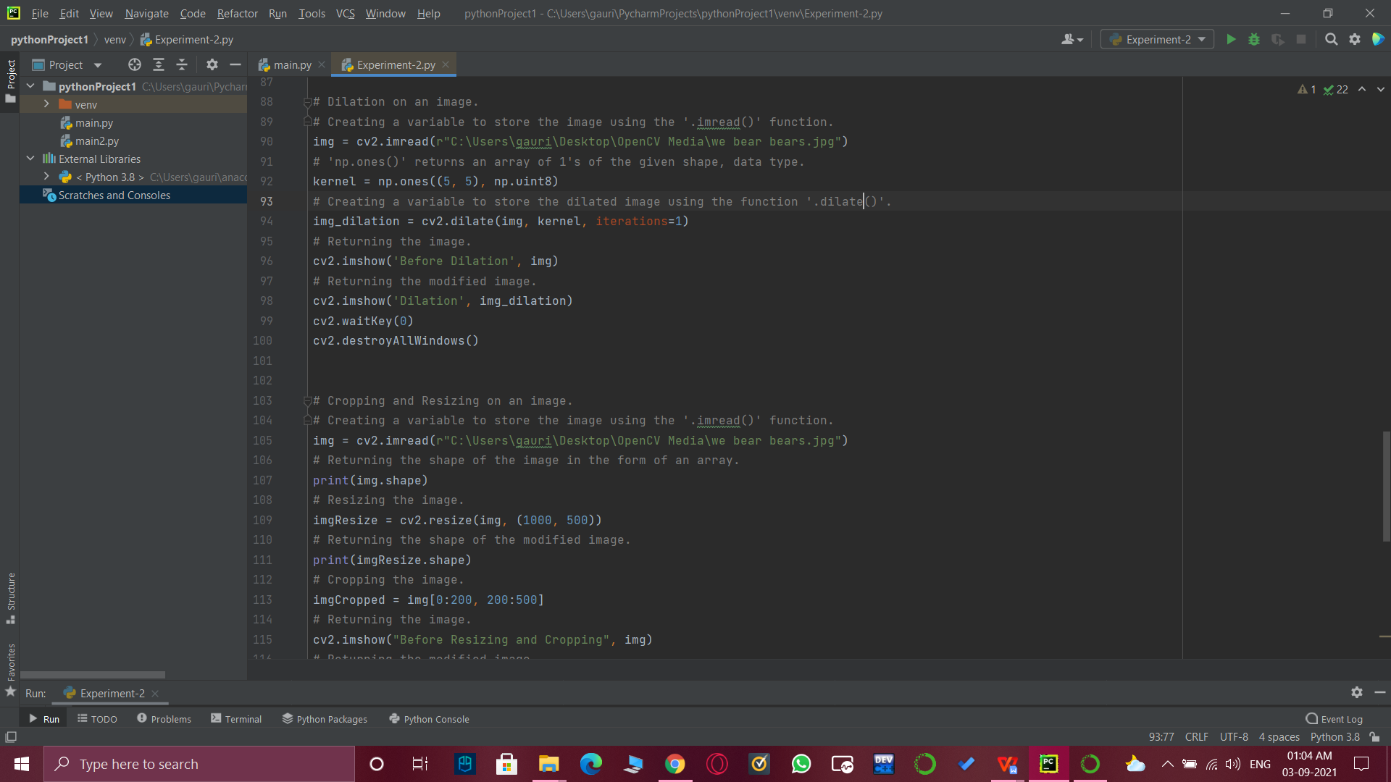

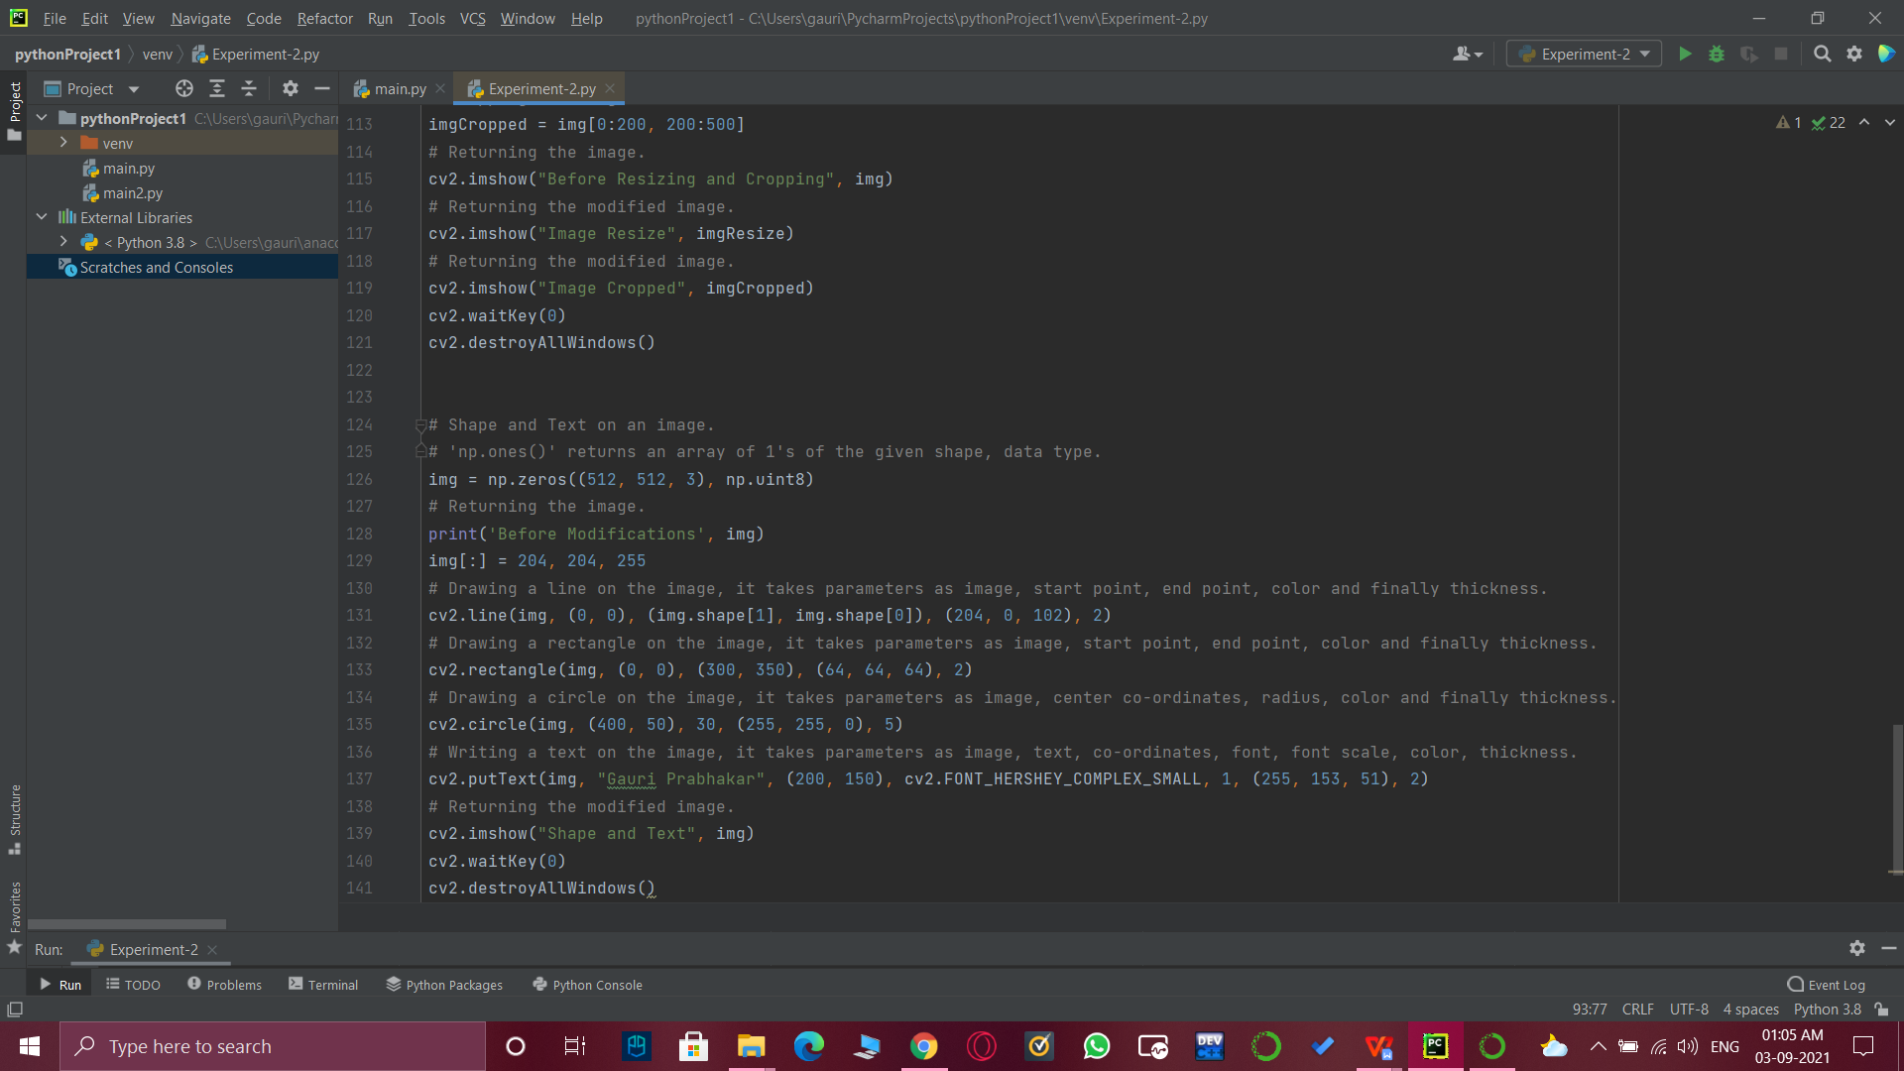

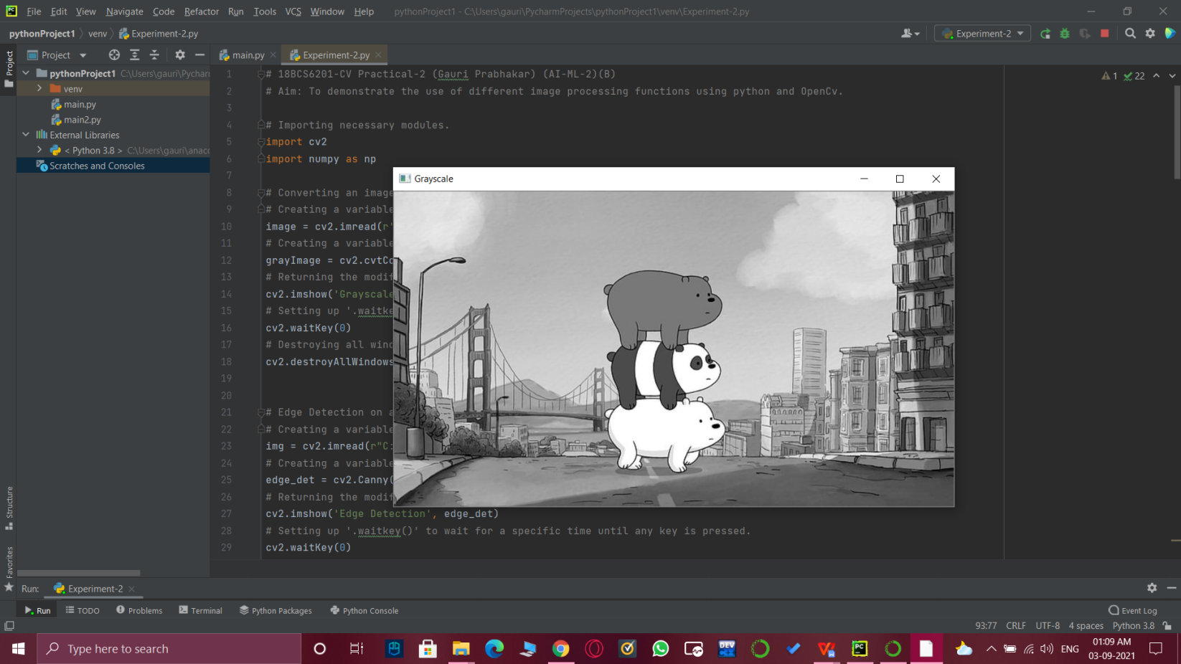

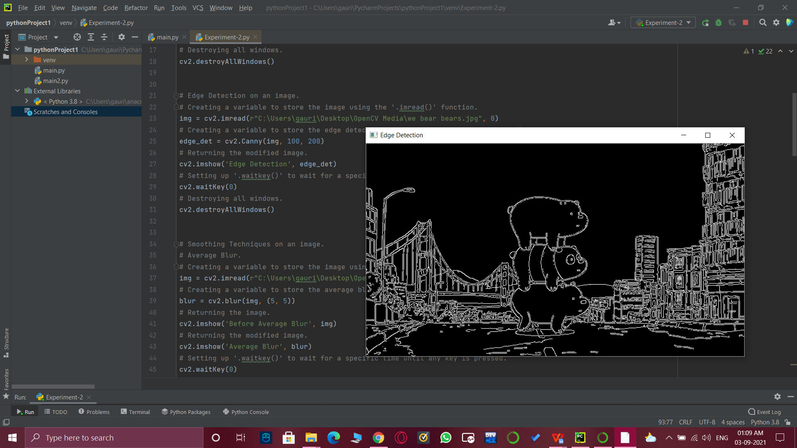

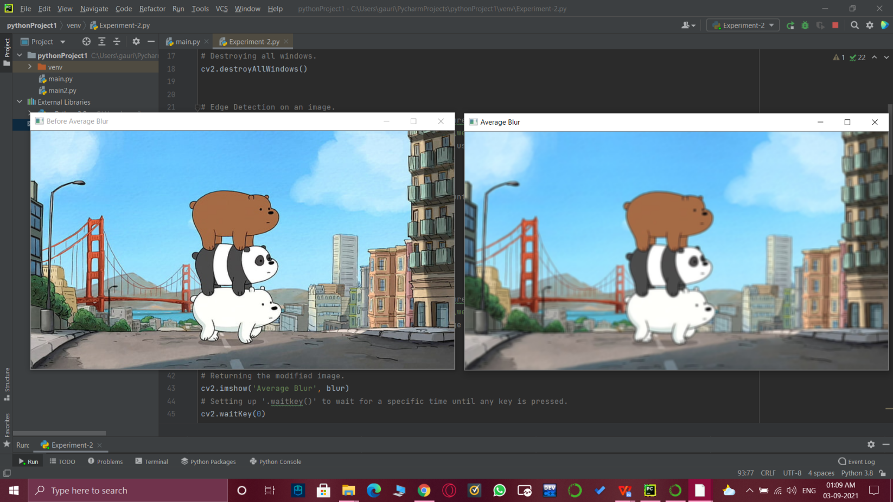

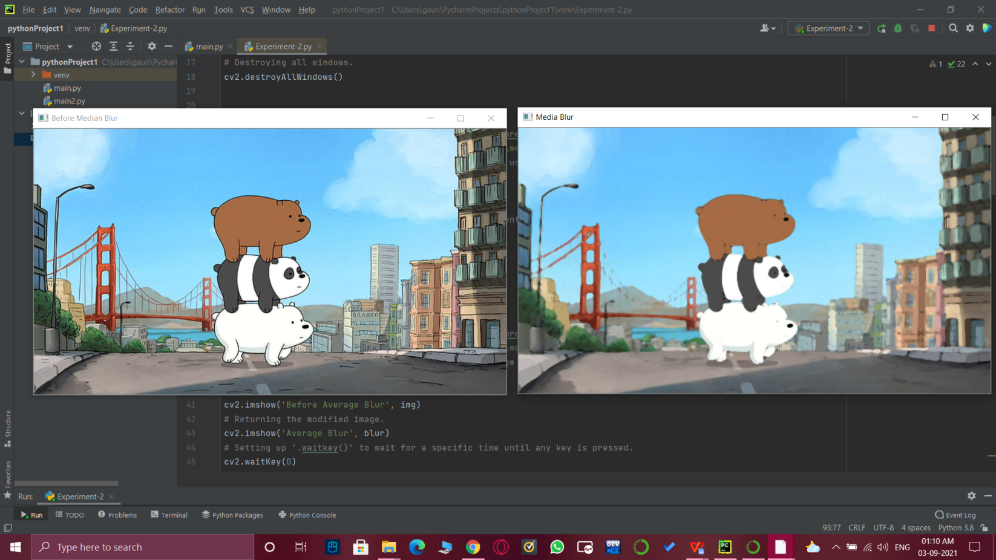

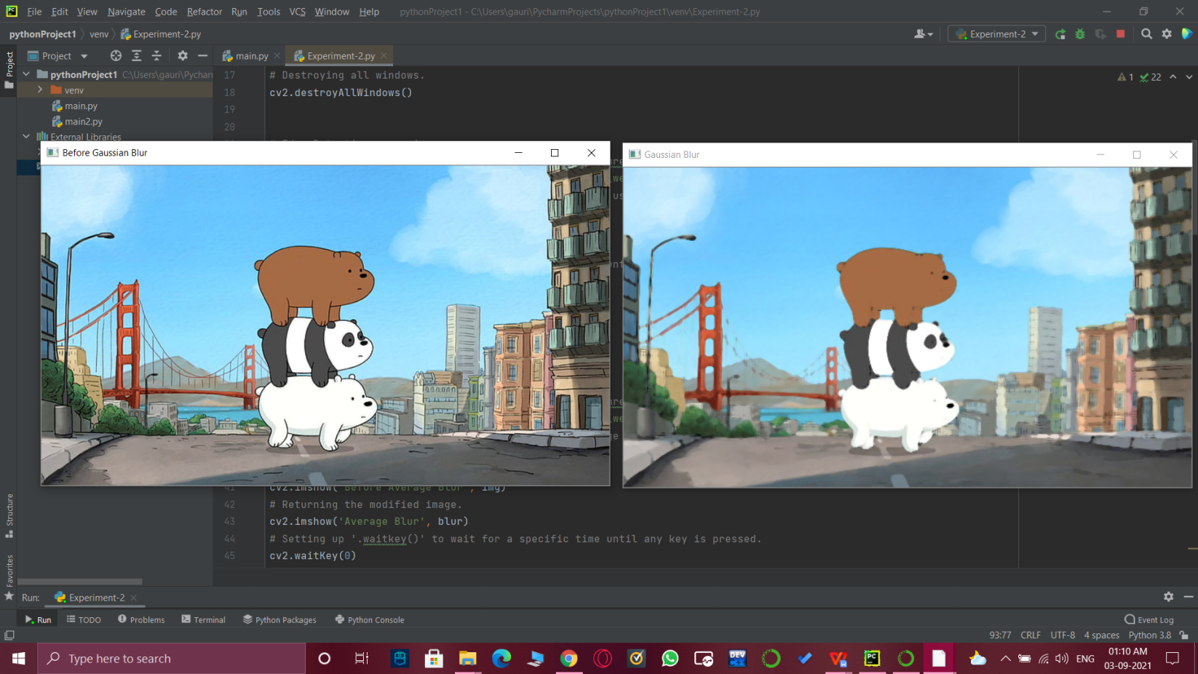

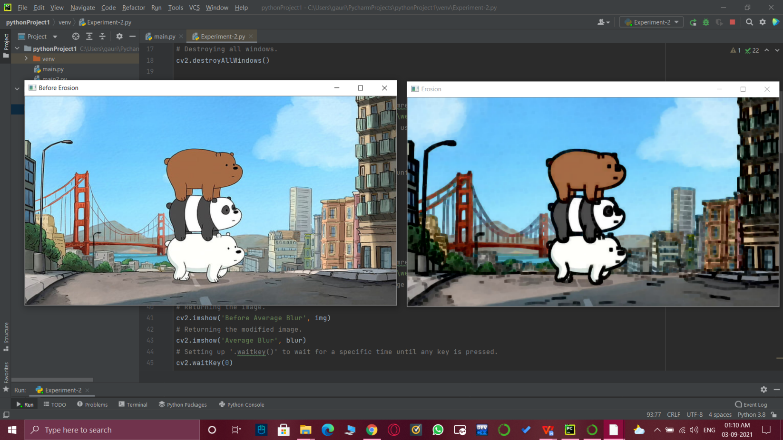

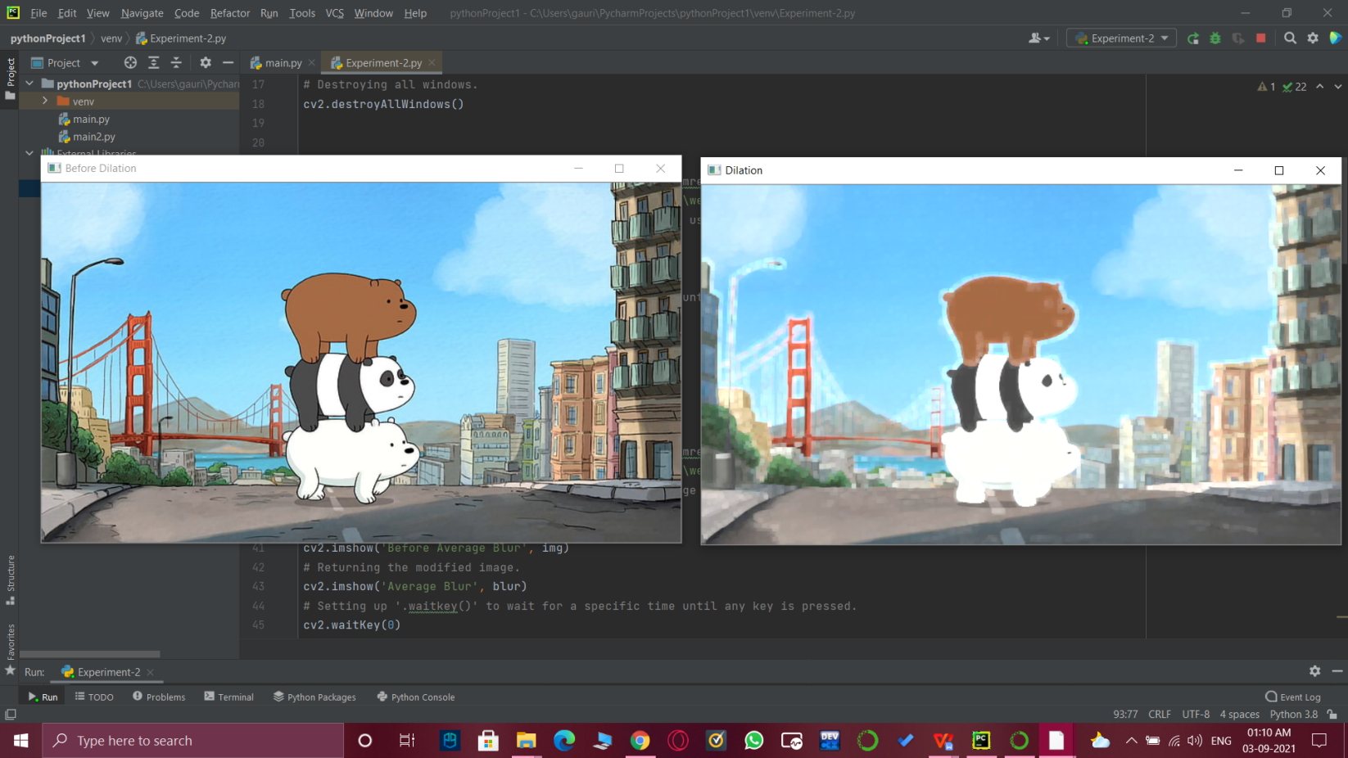

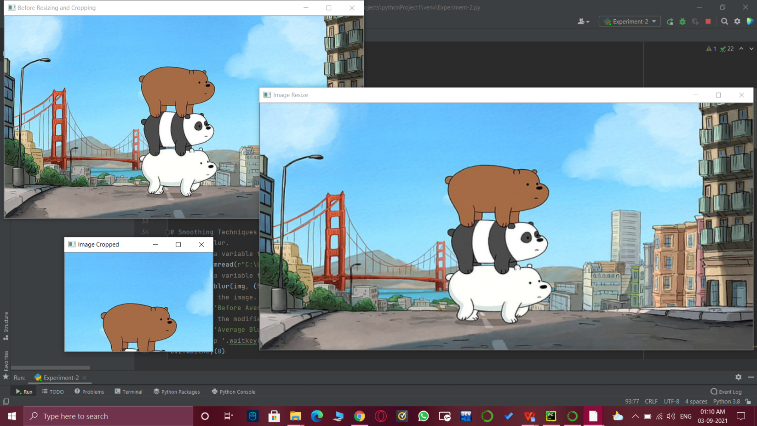

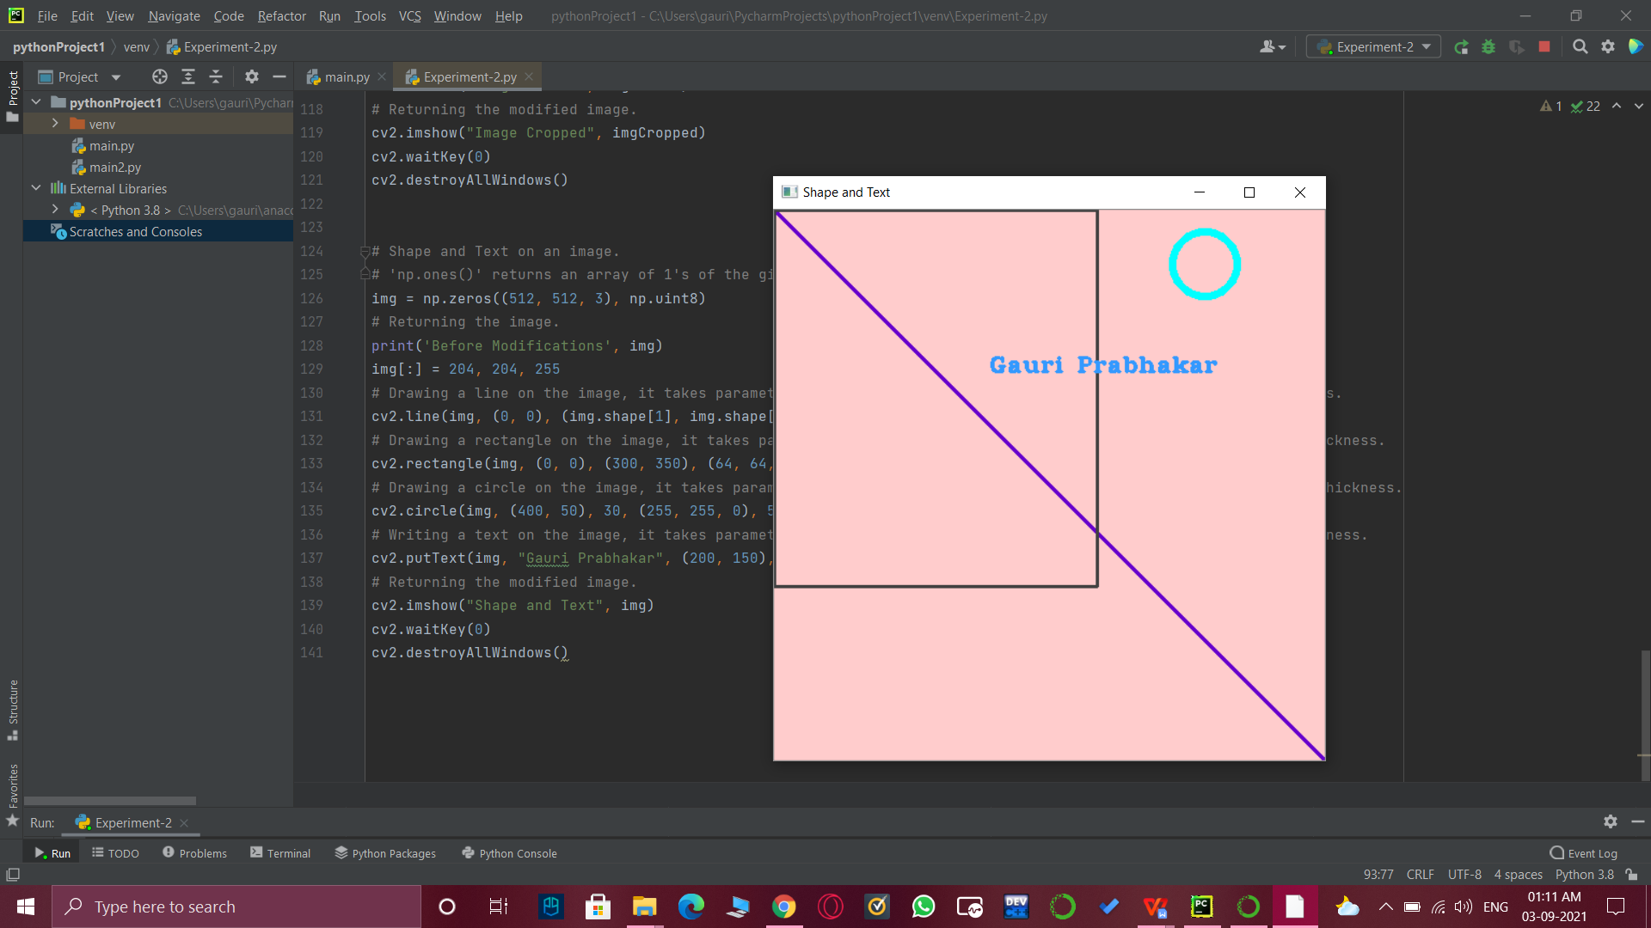

# Learning outcomes (What I have learnt):

* Open CV modules.
* Grayscale images, edge detection.
* Average, Median and Gaussian Blur.
* Erosion and Dilation of an image.
* Cropping and resizing an image.
* Different shapes and text on an image.

**Evaluation Grid (To be created as per the SOP and Assessment guidelines by the faculty):**

|  |  |  |  |
| --- | --- | --- | --- |
| Sr. No. | Parameters | Marks Obtained | Maximum Marks |
| 1. |  |  |  |
| 2. |  |  |  |
| 3. |  |  |  |